Building a Strategy Model to Increase Immigration Information through Expo and Conferences in Indonesia, Soft Systems Methodology Approach

Full Paper

Abstract
Immigration has a strategic role to increase capital inflow through investment, and trading activities that lead to foreign exchange earnings. Conversely, the flow of Indonesian citizens who travel outside the territory of Indonesia will generate funds in the form of remittances. This study aims to analyze the development strategy for increasing the dissemination of information about immigration that is integrated with the soft systems approach methodology. The results of the study show that it is necessary to form an international mega-event, namely the Indonesian Immigration Expo and Conference as a collaborative and integrated platform for providing information that is in line with immigration in Indonesia. This activity acts as a social network because it brings together Embassies, Businessmen, Universities, and Tourism Agencies in one place. The study recommends the involvement of stakeholders in encouraging the collaborative design of activities for each party.

Keywords: Soft systems methodology, Immigration, Collaborative Governance, Mega-Event, Expo, and Conference.

Introduction
Indonesia is one of the most populous countries compared to other Southeast Asian countries. Based on the Worldmeters report, it is recorded that Indonesia occupies the first position as the most populous country in Southeast Asia with 273.52 million people. The data shows that 40.9% of Southeast Asia's population comes from Indonesia. The population is growing by 1.07% every year. This high number certainly has a big impact on various aspects of life, be it the economy, education, or tourism. In terms of the economy, the large number of people causes the availability of jobs to be increasingly limited, encouraging them to migrate to other countries. Not only to obtain a decent economy, population movements or migration of Indonesian people abroad are also motivated by education. According to data from the UNESCO Institute of Statistics in 2021, 53,604 Indonesian students continued their studies abroad and it is predicted that it will increase every year. Therefore, it can be said that the interest of Indonesians to travel abroad is quite high. This motivation is also supported by other reasons, namely work & business reasons, treatment in foreign hospitals, or vacation. According to data from the Central Statistics Agency (BPS) in 2020, it was reported that around 45.91% of the 2.92 million trips abroad were still driven by recreational or vacation reasons.
Immigration itself has a strategic role in nation-building. From an economic point of view, the role of immigration has provided the opportunity to increase revenue in Indonesia. By foreign people and corporations entering Indonesia, it will increase capital flow through investment, and trade activities that could lead to foreign exchange earnings. The flow of Indonesian citizens who travel outside the territory of Indonesia to work, invest, and do business abroad will generate funds in the form of remittances. With the issuance of Regulation of the Minister of Law and Human Rights of the Republic of Indonesia Number 28 of 2021 concerning Immigration Facilities and Facilities in Special Economic Zones, it shows the realization of the government to bring in foreign exchange. The magnitude of immigration's contribution to state revenue can be seen from the Directorate General of Immigration's Public Relations data which stated that Non-Tax State Revenue (PNBP) reached the largest figure in immigration history, namely IDR 4.5 trillion. This figure is dominated by visa service revenue which reaches Rp 2 trillion.
The high interest of the citizen to migrate within or outside the country is an impetus for the Government and other stakeholders to act according to the needs of the community. What is quite unfortunate is that the platform to fulfill the needs of the community towards immigration practically and massively is still relatively minimal. No activity such as exhibitions and conferences can bring together embassies and the general public directly to exchange information efficiently. Expositions and conferences in Indonesia related to employment, tourism, or business are still organized independently and not integrated well. This is in contrast to the characteristics of the migration process itself, which has a multi-dimensional nature. The implementation of immigration services is always in a condition with a high level of dynamics because the immigration function is directly related to human mobility which always pursues change. Therefore, it is necessary to have collaborative governance or the actions of public agencies to interconnect with other stakeholders in making formal and consensus-oriented decisions. Building the capacity to collaborate not only benefits the government but also the other organizations involved. Organizations will benefit from cost savings due to the process of exchanging information on the best practices and a more developed innovation process due to a wider exchange of ideas. Not only that, but related organizations can also make better decisions because they received more information diversity from the partners involved.
Other countries including Hong Kong, Australia, and Canada have Migration Expos that have been integrated with various participants such as educational institutions, recruiters, governments, and businesses to facilitate networking with participants. The existence of these events allows for maximum opportunities for target participants who intend to move abroad temporarily or permanently. Even in Hong Kong, the Immigration Expo is also combined with the Property Expo so that overseas property companies can negotiate directly with consumers. Seeing the readiness of the country, the researcher is interested in analyzing the right actions related to the immigration situation in Indonesia with a soft systems methodology approach. The purpose of this study is to identify each actor related to the problem and propose actions that can meet the immigration needs of the community.

Migration
Immigration is part of the realization of the enforcement of sovereignty over the territory of Indonesia to maintain the orderly life of the nation and state. Law No. 6/2011 on Immigration which includes (i) immigration services, (ii) law enforcement and state security, and (iii) facilitator of public welfare development. Immigration is a matter of traffic of people entering or leaving the territory of Indonesia as well as its supervision to maintain the sovereignty of the state according to legal regulations and immigration legal events (das sein und das sollen). Immigration duties (core business) carried out by the Ministry of Law and Human Rights are in line with the President's work priorities in the field of bureaucratic reform, among others: speed of service and granting permits, eliminating monotonous linear mindsets (system thinking) and being stuck in a comfort zone and being adaptive productive, innovative and competitive. The modern view of migration sees that migration is not limited to individual movement, but also collective. The process is not voluntary but also thoroughly organized so that many other aspects are interconnected. Based on the Law of the Republic of Indonesia Number 6 of 2011 Article 1 Point 3, there is a statement related to the immigration function or the chess function of immigration. Based on this article, the role of immigration includes four functions, namely immigration services, law enforcement functions, security functions, and a facilitator of community welfare development. Immigration Services is one of the functions that reflect services in the form of making documents to Indonesian and foreign nationals. The Law Enforcement function implies that migration has Immigration has the authority to maintain law enforcement in Indonesia be it administratively to poustinia. The third function, Security, reflects the screening process on the arrival and departure of foreigners as a form of preventive action against state sovereignty. The Development Facilitator function has the content of immigration services that affect the economy. This is realized in the form of granting permission for Indonesian citizens and foreigners to enter and exit in the implementation of economic activities.

The monopoly resources are one of the issues in Indonesia's immigration sector. Purnama Stated that the immigration office is the sole organization in charge of managing public services in the immigration industry and that other parties are not involved, particularly in the area of human resources. This is a result of a number of things, including the Immigration party's exclusive ability to monitor and stop foreign nationals from entering Indonesia. Additionally, it is impossible to coordinate the expertise and analysis of Immigration personnel with other parties. So far, cooperation between the Indonesian immigration sector and UNHCR has been carried out to address problems related to refugees in Indonesia. Cooperation between the two organizations includes local settlement support, refugee repatriation, and resettlement in third countries.

Economic growth
The rate of economic growth a time will be influenced by the main factors, namely production factors and technological advances that are increasingly developing. Over time, the government plays an active role in the country's economy, including the implementation of taxes and handling inflation, which is influenced by technology and production factors themselves. Investment that generates productivity also plays an important role in economic growth. A cross-country study by Eifert found that the level of corporate investment in relatively poor countries increased by about 0.6 percent and the economy grew about 0.4 percent faster in the year following reforms to the Doing Business regulations. This growth is associated with increased demand for investment goods by firms, given that productivity gains from increased investment generally lag at least one year. Therefore, productivity improvements allow firms to produce greater output at the same level of inputs, earning higher revenues and ultimately generating greater Gross Domestic Product. Schumpeter has a similar perspective on economic growth. According to him, entrepreneurship in the form of innovation and creativity is the most important factor in an economy. The output produced by entrepreneurs is what Schumpeter emphasizes that innovation is needed as a competitive advantage and economic driver. These business innovations include quality goods that have never been invented, innovations in the form of effective business methods, and market expansion to increase exports and other economic resources. The existence of this innovation will provide benefits that are a source of funds for existing capital accumulation.
One of the main policies of the Directorate General of Immigration is to encourage the nation's economic growth. Immigration is required to always develop various innovations and implement various policies that can accelerate the economy, as well as involve elements of society. Yasonn Minister of Law and Human Rights of the Republic of Indonesia, said that a strategy to diversify the types of visas that are aligned with current trends can be implemented to accommodate this. However, this must be preceded by thorough research including comparisons with applications in other countries.

Collaborative Governance
As knowledge and institutional capacity grow, the trend toward collaboration is increasing. Over time, the network structure in public policy implementation has become more complex, both internally and externally. Therefore, it is necessary to collaborate deeply to ensure that each party can depend on the other and shift their interests. This is also supported by the development of increasingly specialized and complexly dispersed knowledge, which encourages collaboration to occur. The collaboration process is unique to governance and is not about which one is better, but what collaboration processes are successful in benefiting the various organizational parties involved. Within the scope of government, collaboration is also realized through the development of collaborative governance. According to Ansell & Gash (2008), Collaborative governance is a governance strategy that integrates relevant stakeholders to gather in a forum and form a collective agreement in the form of public policy. According to Gharaee et al. (2023), the most important strength in applying public-private partnership is to improve access to service, especially for marginalized people, improve the quality of services, and satisfy the people involved. The success of implementing a system will be determined based on the application of a culture of collaboration and a strong commitment to a team. There are six criteria for supporting this collaborative governance. The first criterion is that the forum is initiated by a public institution. Second, participants in the forum include non-governmental parties. The third criterion is that participants need to be directly involved with policy formulation and not just “consulting” with the government. On the fourth criterion, meetings in the form of this forum need to be held routinely and carried out formally. The next or fifth criterion, the policy that is decided must be based on agreement. On the last criterion, the main focus of the collaboration is management or public policy.

Mega-Event as A Social Network
Mega-Events can be classified based on their size, duration, impact, global reach, and significance. According to Müller, 2015, a mega event is a moment with a fixed duration which, (a) attracts a large number of visitors, (b) has a wide reach, (c) costs quite a lot, and (d) has a major impact on the environment and population. As a form of activity that attracts the attention of visitors globally, this mega-event can effectively encourage tourism, boost the economy, and celebrate the culture of the host country itself. Based on the cultural aspect, the existence of a mega-event can increase awareness of the host country as the organizer, encourage cultural exchange, and preserve the local culture itself. This will certainly have an impact on the interest of foreign investors to carry out economic cooperation that is profitable for business people in that country. Expo is one part of a mega-event that can offer various kinds of benefits desired by the public as connoisseurs of new experiences. Kesrul stated that MICE or Meeting, Incentive, Convention, and Exhibition is an activity with tourism elements that combine leisure and business by involving various groups of people collaboratively. The convention and exhibition industry is one of the contributors to foreign exchange in the tourism sector because it involves many human resources who are experts in their respective fields. Indonesia itself is ranked eleventh as a country with meeting and conference organizers in the Asia Pacific region. On the one hand, the mega-event provider also needs to provide the best quality of service and ensure that the events held can generate more value for visitors. Therefore, thorough collaboration and cooperation are needed in achieving effectiveness at each mega-event.

Method

This research uses soft systems methodology or SSM in modeling immigration-related activities. This soft systems approach is appropriate for this study because it can view complex social situations and involves various points of view. This is in accordance with research from Suryaatmaja et al. (2020) who used SSM because of its role in supporting the exploration of a situation and solving problems related to Agile Software Development by utilizing structured discussions. SSM is considered capable of providing an accommodation function that can find another version of the situation that is acceptable to all parties. According to P. Checkland & Poulter (2020), soft systems methodology is based on the idea that the situation that people observe is part of a system of human activities, where we can choose one or more relevant activities to compare with the real world. Existing research has proven that SSM can encourage collaboration and coordination of various parties. In the research by Devi et al. (2023), SSM is implemented to provide new ways and overcome overlapping problems so that a culture of collaboration is growing in Indonesian companies. According to Budiarso et al., 2022, SSM acts as an appropriate method to study collaboration. This is due to its ability to provide a broad view of the conflicting social world and find accommodations that are relevant to both the organizational and mutuality dimensions of the collaboration process. The research framework used will be based on Checkland's soft systems framework, as attached in Figure 1. Data in this study was collected through interviews and document studies. The use of interviews was used to capture problematic situations related to international migration programs.
There are seven stages of the soft systems methodology applied to this research. According to Checkland and Poulter, the seven stages include the following: 1) problem situation considered problematic, (2) problem situation expressed, (3) root definition of purposeful activity, (4) conceptual models of the systems named in the root definition, (5) comparison of models and real worlds, (6) systematically desirable and culturally feasible changes, (7) action to improve situations.

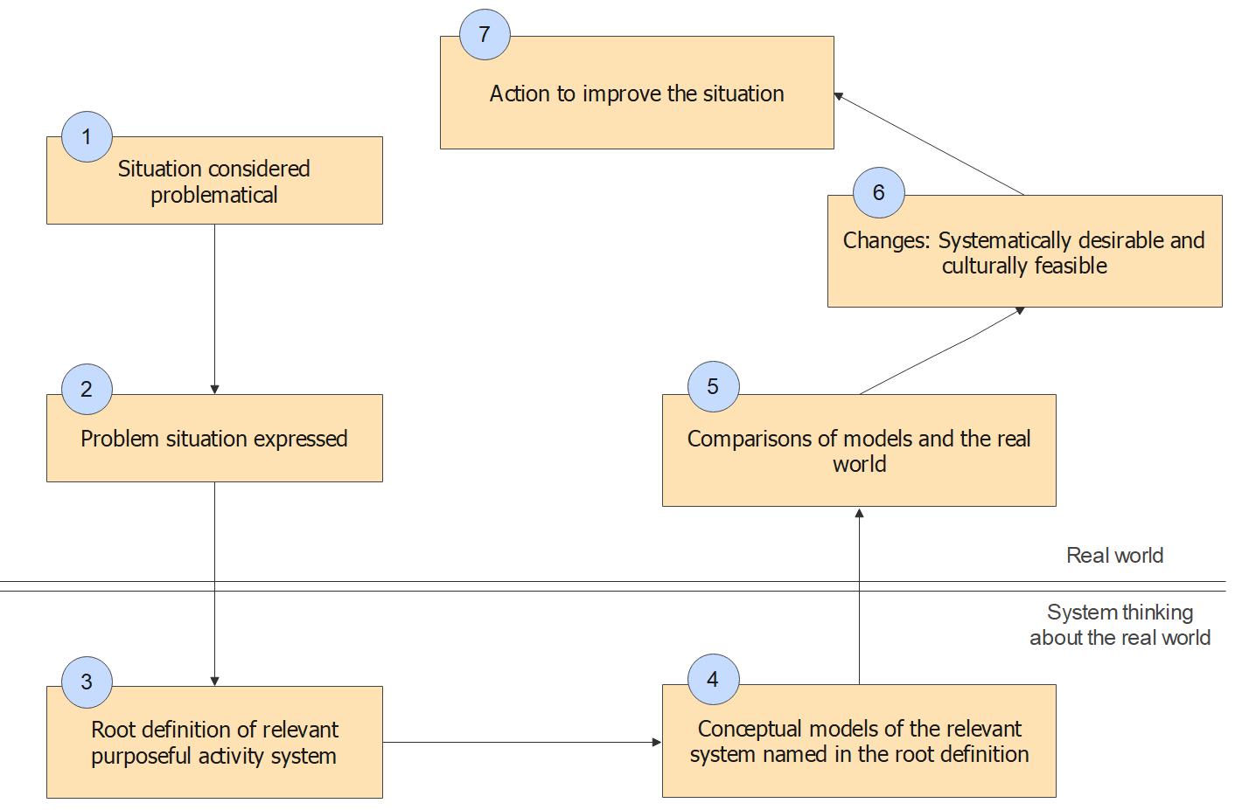

Figure 1. Research Methodology
Source: Adopted from SSM Stages by Checkland (2000; 2006; 2020)

Findings and Discussion

Stage One: Problem Situation Considered Problematic
The need for people to migrate from Indonesia or vice versa is quite diverse. There are four main factors behind this reason, namely work and business reasons abroad, getting treatment from foreign hospitals, education, or just running vacation activities. These motivations are also driven by the increasing number of productive ages in Indonesia so the need for people to go abroad is increasing. However, Indonesia does not yet have an appropriate platform to channel information and communication related to immigration aspects. So far, information related to immigration is still run independently by certain parties through their respective means. According to research conducted by Laricha et al., (2018), the service value based on the Citizen Satisfaction Index for the Jakarta Immigration Office is still relatively good. Even though it is said to be good, there are differences and many negative ratings which express disappointment at the Jakarta Immigration Office because the services provided are unsatisfactory. The provision of this limited information has resulted in the emergence of several problems that are detrimental to society, namely in the form of fraud from agents, human trafficking, the emergence of extortion, and illegal migration. Government involvement is still considered low in providing information and supervision of irresponsible foreign travel agents. This statement was conveyed in the results of an interview with one of the residents, namely: "It is hoped that the Government will play a more active role in supervising the travel agent business which is irresponsible and commits a lot of fraud to the detriment of consumers." The public in general often gets adverse treatment, both in terms of time and material, from illegal travel agent business practices without the knowledge of the consumers themselves. Not only that, but the lack of information related to a complicated migration system also has an impact on business people. Many investors and tourists have expressed difficulties in obtaining a residence permit in Indonesia due to the lack of a unified and convoluted migration system. One possible reason for this immigration bottleneck is the difficulty in coordinating visa approvals with immigration-prone countries.
On the other hand, Indonesian businesses also find it difficult to cooperate with foreign parties, even though the government has developed convenience in terms of policies. The difficulty in accessing foreign investors is due to the lack of links or connections to these external parties. This is in accordance with the opinion of the businessman in the interview: "Cooperation with foreign parties can only be easy if you have a link or connection. If you already have a connection, usually through the PIC or a third party to facilitate cooperation. It would be even better if the government could build a network to facilitate such cooperation". In realization, the Government has issued an online-based platform called OSS to provide one-stop services related to business licensing. The implementation of OSS is still not considered effective because the Government and local governments are not integrative enough, the provision of licenses is not complete, and it is still unstable with the changing Omnibuslaw. This was stated by one of the other entrepreneurs: "Often government efforts are hampered due to unsynchronized implementation, for example, OSS is hampered due to overlapping rules due to Omnibuslaw, sectoral egos of ministries of institutions and local governments that hamper investors' ease of doing business". Based on the interviews that have been conducted, it can be concluded that each interviewee feels that the Government itself has not created an effective "one-stop" place that can become a center of immigration information, whether for business, education, or permanent residence. Not only that, migration issues related to the issue of refugees and asylum seekers also still need to be discussed and addressed According to Wicaksari (2018), cooperation between the immigration office and IOM (International Organization for Migration) needs to be done to protect refugees and asylum seekers whose rights are still threatened, especially the rights of children in it. The existence of this complex problem is a problematic situation that will be investigated further with the soft system method in this research.

Stage Two: Problem Situation Expressed
The second stage of this research is to transform a complex problematic situation into a network of information described in the rich picture. The rich picture can provide an overview of the complexity of a problem. This is because immigration issues involve many interests with different resource capabilities. Based on the results of the interview, the Government itself has made several efforts to provide information related to immigration, by the following POLRI statement: "The efforts that have been made are the establishment of immigration offices in the regions, improving the class of immigration offices, establishing immigration detention centers, as well as through the Public Relations Bureau to cooperate with mass & online media". The problem in this situation is that there is no integrated and easily accessible information service for the public regarding immigration from other countries. The phenomenon of migration in Indonesia is a complex matter because it involves various parties, both government and private. Therefore, collaborative governance is needed as an effort to analyze the situation more broadly and produce appropriate policies. This problem does not originate from the government alone, but also from other stakeholders related to migration affairs. There is interaction between the government, businesses, the military, and the general public in this problematic situation. This research utilizes interviews and document studies to determine the interaction of each party involved. To comprehensively capture the phenomenon, the researcher uses a rich picture as depicted in Figure 2 below.
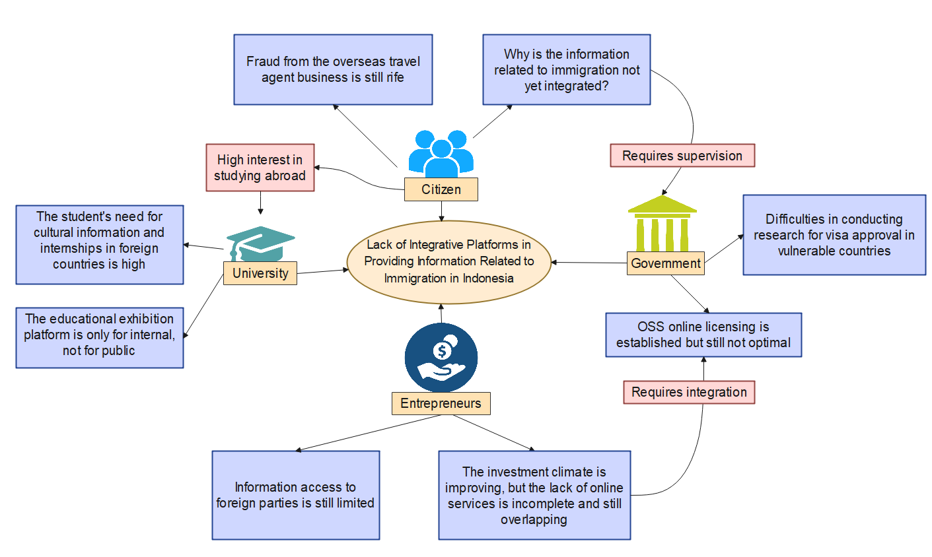

Figure 2. Rich Picture of Immigration Phenomena in Indonesia
Source: Research Processed Data, 2023

Stage Three: Definition of the Relevant System
Root definition is the next stage to describe the transformation process and situational changes that might be made in the real world. Based on the rich picture above, it can be seen that each stakeholder still feels the complexity of the convoluted migration system. According to Nuriyanto (2016), it is the government’s duty to meet the needs of all citizens through a government system that supports the creation of quality public services that meet the basic needs and civil rights of every citizen over public goods, public services, and administrative services, especially in the immigration sector. Therefore, the root definition of the existing situation is to improve information access in an integrated platform related to the international migration process.The important step in massively improving information sharing is to organize an integrated platform that can bring together aspects of business, recruiters, universities, travel agents, and government in one place, through Expo and Conference. This event’s main goal is to create an effective and efficient information network for visitors. The activity is also done to avoid third parties to commit corruptive acts because every interested party can meet face-to-face without certain restrictions. The existence of this forum is also important in the face of technological advances and fierce business competition, so it is necessary to have a meeting of related countries in obtaining actual information. Other than that, this event is also in line with the priorities of the Indonesian immigration sector that encourage and promote innovation by involving elements of society to develop the nation's economy. According to Gharaee et al., the most important strength in applying public-private partnership is to improve access to service, especially for marginalized people, improve quality of services, and satisfy people involved. The existence of this event can fulfill those purposes, where access to immigration information will be more evenly distributed and the quality of service can also satisfy future visitors.
In the exhibition section, the event will invite foreign embassies in Indonesia to form booth stands. Each booth stand will be filled with various information such as universities, vacation spots, pilgrimage sites, immigration, hospitals, and job vacancy information. Not only conducting exhibitions, but this activity will also hold a conference as a forum for collaboration and discussion by discussing strategic and actual issues related to immigration. Based on the consideration of the root definition, the PQR formulation is as follows: Build an all-in-one information platform that is integrative and collaborative with Ministries, Embassies of Friendly Countries in Indonesia, Businessmen, Universities, the General Public, and Event Organizers to create the Indonesian Immigration Expo and Conference to optimize the effective and efficient dissemination of immigration information. This activity is appropriate as the development of the globalization era supports the prospect of the MICE (Meetings, Incentives, Convention, and Exhibition) industry growing.
In developing a change, this study uses CATWOE (Clients, Actors, Transformation, Weltanschauung, Owners, and Environment) analysis to analyze each role and process of the proposed action. The following is a CATWOE analysis of the root definitions that have been made in Table 1 below.

Table 1. CATWOE Analysis on Root Definition

C | General public
A | Directorate General of Immigration, Ministry of Foreign Affairs of the Republic of Indonesia, Event Organizers, and Embassies.
Q | Lack of access to information on integrated aspects of international migration 🡪High level of awareness and understanding of local and foreign communities on aspects of immigration in Indonesia
W | Creating Indonesian Immigration Expo and Conference activities that can integrate the needs of the citizen regarding immigration from each country in various aspects, namely education, tourism, residence permits, and investment.
O | Directorate General of Immigration
E | Regulatory issues and costs involve interested parties.
Source: Research Processed Data, 2023

Developing Conceptual Model
At this stage, the development of a conceptual model is carried out based on the root definition that has been built previously. In building the Indonesian Immigration Expo and Conference, some stages need to be carried out by various parties involved. Based on the conceptual model, the planning process in the first stage is an important foundation where the destination organizing the Expo & Conference must decide on the best international criteria and standards. According to Rudatin (2021), five criteria need to be met, which include aspects of cleanliness, the airport as the main gateway for tourists, the venue where the event is held, clear procedures, and accommodation services. The existence of clear standards is important because sustainable system implementation will require adherence to internal governance and optimization of operating procedures. These stages are described in the following conceptual model.

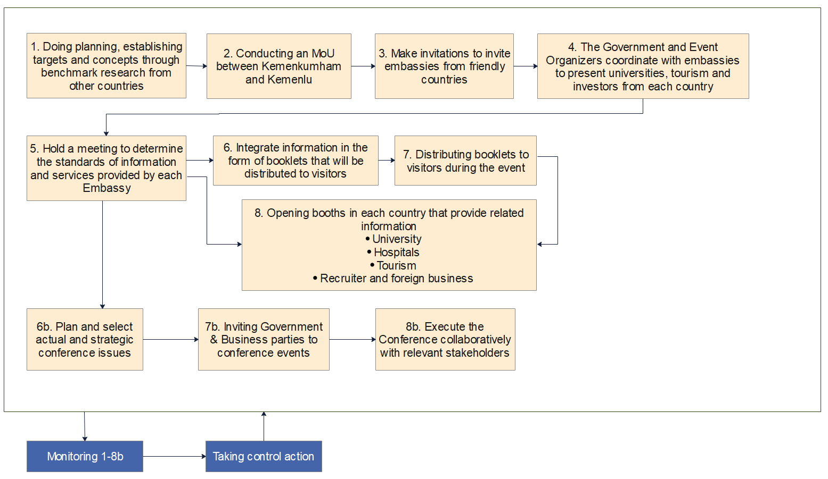

Source: Research Processed Data, 2023
Figure 3. Conceptual Model Based on Root Definition

Stage Five: Model Comparison With the Real World
Stakeholders compare the conceptual model with the real world through several questions, namely "Do the activities in the model occur in the real world? How is the activity realized in the real world?". This comparison is carried out to obtain changes that can arise and reach the right consensus to implement these changes.

Table 2. Comparison of the Model and the Real World
Activity | Exist? | How? | Who? | Good or Bad | Alternatives?
Doing planning in the form of event targets and concepts through research from benchmarks from other countries | Yes | The government is doing a benchmark in holding the Trade Expo concept | Ministry of Trade | Good | The government can evaluate the implementation of the Immigration Expo from abroad.
Activity | Exist? | How? | Who? | Good or Bad | Alternatives?
Doing MoU between the Event Organizer and the Government | Yes | The government has collaborated with the Event Organizer to organize the Trade Expo event | Ministry of Trade | Good | The Ministry of Law and Human Rights can work together with trusted organizers in realizing the Immigration Expo
Inviting Embassies from friendly countries to the event | No |  |  |  | Organizing an International event with Embassy involvement
The government and event organizers coordinate with embassies to present universities, tourism, and investors from each country | No |  |  |  | The government is more involved with other stakeholders in cooperation
Hold a meeting to determine the standard of information and services provided by the Embassy | No |  |  |  | Collaborate with Embassies in disseminating information related to immigration for each country
Integrating information in booklet form | Yes | Immigration already has a Guidebook regarding the immigration process | Kemenkumham | Good | The government can release a booklet containing integrated immigration information including information from other countries
Distributing information booklets related to immigration to visitors | No |  |  |  | Distributing information booklets to visitors to the Indonesian Immigration Expo & Conference
Activity | Exist? | How? | Who? | Good or Bad | Alternatives?
Opening booths for each country | No |  |  |  | Each country through its embassy can provide complete information through booths
Plan and select actual and strategic conference issues | Yes | The ministry has been active in organizing conferences to discuss certain issues | Ministry in Indonesia | Good | The government through the Ministry of Law and Human Rights can discuss immigration issues more actively at conferences involving other countries.
Inviting Government and Business Parties to Conferences | Yes |  | Ministry in Indonesia | Good
Collaborative execution of conferences with relevant stakeholders | Yes |  | Ministry in Indonesia | Good
Source: Research Processed Data, 2023

Stage Six: Changes Systematically Desirable and Culturally Feasible
The next stage in the soft systems methodology process is to analyze the desired changes systematically and feasibly based on cultural aspects. When viewed systematically, the procurement of the Indonesian Immigration Expo and Conference is a form of realization of the immigration function in providing immigration services, law enforcement, state security, and facilitators in the development of community welfare. The core immigration tasks carried out by the Ministry of Law and Human Rights are in line with the President's work priorities after the bureaucratic reform, among others, namely the acceleration of services and permits, the application of systemic thinking to replace the monotonous flow of thinking and play an adaptive role productive, innovative and competitive. The existence of Expo and Conference activities collaboratively is a form of innovation and commitment of the Ministry of Law and Human Rights in carrying out its functions, so this activity can be said to be "systematically desired". Culturally, the Indonesian Expo and Conference activities are also worth doing because they have an element of novelty and open up new opportunities to various parties. This also has a positive effect on every stakeholder involved, namely the Ministry of Law and Human Rights, Foreign Investors, State Embassies, Educational Institutions, and Private Parties.

Stage Seven: Action to Improve Situation
This stage is the content of the actions used to fix the problem. Synergy at the Ministry of Law and Human Rights, especially the Directorate General of Immigration, along with the Ministry of Foreign Affairs to cooperate collaboratively with Embassies and Event Organizers in making the Indonesian Immigration Expo and Conference a success. This collaboration is important to provide integrative and comprehensive information to the target audience. It is also important to implement this action to achieve collaborative governance with the same vision and goal of providing the best service to the public. On the other hand, the general public as target visitors also needs to play an active role by actively participating in the exhibition.

Conclusion
This research uses soft systems methodology to provide recommendations for action to improve the dissemination of immigration information that is integrated and collaborative with various parties. Based on the stages of research that have been carried out, the effort in realizing the objectives of this research is to organize the Indonesian Immigration Expo and Conference as a forum for information related to immigration and other aspects. These activities will not be formed without collaborative governance between the Government and Embassies, Educational Institutions, Hospitals, and Businesses that have their respective roles. This research has a great contribution to business performance through the ease of foreign investment, students who have an interest in studying abroad, job seekers who are looking for job opportunities abroad, to the general public who are looking for international vacation destinations. This is because the Indonesian Immigration Expo and Conference is an effective social network for connecting international opportunities. Not only a forum for information exchange, but the recommendation also offers a Conference as an effort to provide open space for discussion on certain issues that are important in the immigration process with each related country. Future research is expected to consider the aspect of digital services from the Government in overcoming immigration-related problems, especially from the aspect of foreign capital investment.

References
Alwi, & Susanti, G. (2022). Effectiveness Of Managing Network Structure Through Local Collaborative Governance Capacity In The Implementation Of Food Security Policy In Indonesia. Journal of Positive School Psychology, 6(6), 4496–4504. http://journalppw.com
Ansell, C., & Gash, A. (2008). Collaborative governance in theory and practice. Journal of Public Administration Research and Theory, 18(4), 543–571. https://doi.org/10.1093/jopart/mum032
Antaranews.com. (2023, January 26). Human Resource Development and Economic Improvement Become Immigration Priorities. Https://Www.Antaranews.Com/Berita/3365703/Pengembangan-Sdm-Dan-Peningkatan-Ekonomi-Jadi-Prioritas-Imigrasi.
Budiarso, Putro, U. S., Sunitiyoso, Y., & Fitriati, R. (2022). Constructing the collaborative Working Relationships in one of the Big Four Firms. Systemic Practice and Action Research, 35(5), 679–709. https://doi.org/10.1007/s11213-021-09588-3
Budiarso, Sarjono Putro, U., Sunitiyoso, Y., & Fitriati, R. (2021). How do design parameters of firm governance affect collaboration process dimensions in professional service firm? Heliyon, 7(11). https://doi.org/10.1016/j.heliyon.2021.e08431
Checkland, P. (2000). Soft systems methodology: a thirty year retrospective. Systems Research and Behavioral Science, 17(1).
Checkland, P. B., & Poulter, J. (2006). Learning for Action: A Short Definitive Account of Soft Systems Methodology and its Use for Practitioners, Teachers and Students. Wiley.
Checkland, P., & Poulter, J. (2020). “Soft systems methodology”, in Reynolds, M. and Holwell, S. (Eds), Systems Approaches to Making Change: A Practical Guide (Second Edition). Springer-Verlag London Ltd.
Devi, E. T., Wibisono, D., Mulyono, N. B., & Fitriati, R. (2023). Designing an information-sharing system to improve collaboration culture: a soft systems methodology approach in the digital service creation process. Journal of Enterprise Information Management. https://doi.org/10.1108/JEIM-08-2022-0294
Ditjenim. (2022, December 30). Siaran Pers : Imigrasi Cetak PNBP 4,5 Triliun dan Sederet Terobosan Layanan di Tahun 2022. Direktorat Jenderal Imigrasi Kementerian Hukum dan HAM Ri.
Eifert, B. P. (2009). Do Regulatory Reforms Stimulate Investment and Growth? Evidence from the Doing Business Data, 2003-07 (No. 159). http://www.cgdev.org/content/publications/detail/1420894
Fernando, D., Putra, R. P., Yulanda, S., & Imigrasi Badan Pengembangan Sumber Daya, P. (2021). KERJASAMA DIREKTORAT JENDERAL IMIGRASI DENGAN UNHCR (UNITED NATIONS HIGH COMMISSIONER FOR REFUGEES). Jurnal Sains Riset |, 11(1), 57. https://doi.org/10.47647/jsr.v10i12
Gharaee, H., Azami Aghdash, S., Farahbakhsh, M., Karamouz, M., Nosratnejad, S., & Tabrizi, J. S. (2023). Public-private partnership in primary health care: An experience from Iran. Primary Health Care Research and Development, 24(3). https://doi.org/10.1017/S1463423622000561
Hadya, D. (2021, December 29). Berlibur, Tujuan Utama Penduduk Indonesia ke Luar Negeri Saat Pandemi. Databoks.
Hansen, M. T., & Nohria, N. (2004). How to build collaborative advantage. MIT Sloan Management Review, 46(1), 22–30.
Horne, J. (2007). The four “knowns” of sports mega-events. Leisure Studies, 26(1), 81–96. https://doi.org/10.1080/02614360500504628
Laricha, L., Kosasih, W., Tri, D., & Permai, R. (2018). PENGUKURAN DAN ANALISIS INDEKS KEPUASAN MASYARAKAT DI KANTOR IMIGRASI JAKARTA. In Jurnal Ilmiah Teknik Industri (Vol. 6, Issue 1).
Lee, C. K., Kang, S. K., & Lee, Y. K. (2013). Segmentation of Mega Event Motivation: The Case of Expo 2010 Shanghai China. Asia Pacific Journal of Tourism Research, 18(6), 637–660. https://doi.org/10.1080/10941665.2012.695287
Mankiw, G. (2016). Principles of Macroeconomics (Eigth Edition). Cengage Learning.
Müller, M. (2015). What makes an event a mega-event? Definitions and sizes. Leisure Studies, 34(6), 627–642. https://doi.org/10.1080/02614367.2014.993333
Natanegara Kartika Purnama, R., Arief Adillah, M., Edi Tando, C., Hukum dan HAM, B., Hukum dan Hak Asasi Manusia, K. R., & Imigrasi, P. (2023). POLICY FOR INCREASING PNBP IN PUBLIC SERVICES IN THE IMMIGRATION SECTOR. 17, 69–80. https://doi.org/10.30641/kebijakan.2023.V17.69-80
Nuriyanto. (2016). Penyelenggaraan Pelayanan Publik Di Indonesia, Sudahkah Berlandaskan Konsep “Welfare State”? Jurnal Konstitusi, 11(3). http://www.kompas.co.id/
Rossa, V. (2022, July 25). Indonesia Jadi Salah Satu Negara dengan Jumlah Siswa Belajar di Luar Negeri Terbanyak di Tahun 2021. Https://Www.Suara.Com/Lifestyle/2022/07/25/121810/Indonesia-Jadi-Salah-Satu-Negara-Dengan-Jumlah-Siswa-Belajar-Di-Luar-Negeri-Terbanyak-Di-Tahun-2021.
Rudatin, C. L., Wardhani, A., Fauzi Mubarak, dan, Niaga, A., Negeri Jakarta, P., & Siwabessy Kampus UI, J. G. (2021). Analisis Kriteria Destinasi Penyelenggaraan Wisata Bisnis (MICE) Pada Masa Pandemi Covid-19. Seminar Nasional Terapan Riset Inovatif (SENTRINOV) Ke-VII, 7(1).
Santoso, I. (2014). Perspektif imigrasi dalam migrasi manusia . Pustaka Reka Cipta.
Santoso, M. I. (2015). Applying Interactive Planning on Public Service Leadership in the Directorate General of Immigration Indonesia. Procedia - Social and Behavioral Sciences, 169, 400–410. https://doi.org/10.1016/j.sbspro.2015.01.326
Setiawan, A. (2020). IMPLEMENTASI FUNGSI KEIMIGRASIAN TERHADAP PERLINDUNGAN PEKERJA MIGRAN INDONESIA (Implementation of Immigration Function for Protection of Indonesian Migrant Workers). Jurnal Ilmiah Kajian Keimigrasian, 3(1), 1–11.
Śledzik, K. (2013). Schumpeter’s view on innovation and entrepreneurship SCHUMPETER’S VIEW ON INNOVATION AND ENTREPRENEURSHIP. Management Trends in Theory and Practice.
Suryaatmaja, K., Wibisono, D., Ghazali, A., & Fitriati, R. (2020). Uncovering the failure of Agile framework implementation using SSM-based action research. Palgrave Communications, 6(1). https://doi.org/10.1057/s41599-019-0384-9
Tenggara, M., Maringka, B., & Hamka. (2019). PERANCANGAN KONFERENSI DAN PAMERAN DI KOTA MALANG TEMA: HIGH-TECH ARCHITECTURE. Jurnal Pengilon, 3(2).
Wang, Y., & Jin, X. (2019). Event-based destination marketing: The role of mega-events. Event Management, 23(1), 109–118. https://doi.org/10.3727/152599518X15378845225384
Wicaksari, T. (2018). Kerja Sama Kantor Detensi Imigrasi dan International Organization For Migration: Studi Kasus Perlindungan Pengungsi dan Pencari Suaka Anak di Rumah Detensi Imigrasi Semarang. Journal of International Relations, 4(3).
Worldometers. (2020). South-Eastern Asia Population. Https://Www.Worldometers.Info/World-Population/South-Eastern-Asia-Population/.

Worldometers, “South-Eastern Asia Population,” Worldometers, 2020, Https://Www.Worldometers.Info/World-Population/South-Eastern-Asia-Population/.
Achmad Setiawan. S, “IMPLEMENTASI FUNGSI KEIMIGRASIAN TERHADAP PERLINDUNGAN PEKERJA MIGRAN INDONESIA (Implementation of Immigration Function for Protection of Indonesian Migrant Workers),” Jurnal Ilmiah Kajian Keimigrasian 3 no. 1 (2020): 1–11.
Vania Rossa, “Indonesia Jadi Salah Satu Negara dengan Jumlah Siswa Belajar di Luar Negeri Terbanyak di Tahun 2021,” Suara.com, 2022, Https://Www.Suara.Com/Lifestyle/2022/07/25/121810/Indonesia-Jadi-Salah-Satu-Negara-Dengan-Jumlah-Siswa-Belajar-Di-Luar-Negeri-Terbanyak-Di-Tahun-2021.
Dwi Hadya Jayani, (2021, December 29). “Berlibur, Tujuan Utama Penduduk Indonesia ke Luar Negeri Saat Pandemi,” Databoks, 2021, https://databoks.katadata.co.id/datapublish/2021/12/29/berlibur-tujuan-utama-penduduk-indonesia-ke-luar-negeri-saat-pandemi
Direktorat Jenderal Imigrasi Kementerian Hukum dan HAM RI, “Siaran Pers: Imigrasi Cetak PNBP 4,5 Triliun dan Sederet Terobosan Layanan di Tahun 2022,” Direktorat Jenderal Imigrasi Kementerian Hukum dan HAM RI, 2022.
Iman Santoso, Perspektif imigrasi dalam migrasi manusia, (Pustaka Reka Cipta, 2014).
Iman Santoso (2015). “Applying Interactive Planning on Public Service Leadership in the Directorate General of Immigration Indonesia,” Procedia - Social and Behavioral Sciences, no. 169 (2015): 400–410, https://doi.org/10.1016/j.sbspro.2015.01.326.
Chris Ansell & Alison Gash, “Collaborative governance in theory and practice,” Journal of Public Administration Research and Theory 18 no. 4 (2008):543–571, https://doi.org/10.1093/jopart/mum032.
Morten T. Hansen & Nitin Nohria, “How to build collaborative advantage,” MIT Sloan Management Review 46 no. 1 (2004): 22–30.
Iman Santoso, Perspektif imigrasi dalam migrasi manusia, (Pustaka Reka Cipta, 2014)
Raden Natanegara Kartika Purnama, Muhammad Arief Adillah, Cahyoko Edi Tando, “POLICY FOR INCREASING PNBP IN PUBLIC SERVICES IN THE IMMIGRATION SECTOR,” Jurnal Ilmiah Kebijakan Hukum 17 (2023): 69–80, https://doi.org/10.30641/kebijakan.2023
David Fernando, Razico P. Putra, Satria Yulanda, “KERJASAMA DIREKTORAT JENDERAL IMIGRASI DENGAN UNHCR (UNITED NATIONS HIGH COMMISSIONER FOR REFUGEES),” Jurnal Sains Riset 11, no. 1 (2021): 57, https://doi.org/10.47647/jsr.v10i12
Gregory Mankiw, Principles of Macroeconomics (Eigth Edition), (Cengage Learning:2016).
Benjamin Eifert, “Do Regulatory Reforms Stimulate Investment and Growth? Evidence from the Doing Business Data,” No. 159 (2009), http://www.cgdev.org/content/publications/detail/1420894
Karol Śledzik, “SCHUMPETER’S VIEW ON INNOVATION AND ENTREPRENEURSHIP.” Management Trends in Theory and Practice, (2013).
Gregory Mankiw, Principles of Macroeconomics (Eigth Edition), (Cengage Learning:2016).
Antaranews.com, “Human Resource Development and Economic Improvement Become Immigration Priorities,” 2023, Https://Www.Antaranews.Com/Berita/3365703/Pengembangan-Sdm-Dan-Peningkatan-Ekonomi-Jadi-Prioritas-Imigrasi.
Alwi & Gita Susanti, “Effectiveness of Managing Network Structure Through Local Collaborative Governance Capacity In The Implementation Of Food Security Policy In Indonesia,” Journal of Positive School Psychology 6 no. 6 (2022): 4496–4504, http://journalppw.com.
Alwi & Gita Susanti, “Effectiveness of Managing Network Structure Through Local Collaborative Governance Capacity In The Implementation Of Food Security Policy In Indonesia,” Journal of Positive School Psychology 6 no. 6 (2022): 4496–4504, http://journalppw.com.
Budiarso, Utomo Sarjono Putro, Yos Sunitiyoso & Rachma Fitriati, “How do design parameters of firm governance affect collaboration process dimensions in professional service firm?” Heliyon 7 no. 11 (2021), https://doi.org/10.1016/j.heliyon.2021.e08431.
Ervia Tissyaraksita Devi, Dermawan Wibisono, Nur Budi Mulyono, & Rachma Fitriati, “Designing an information-sharing system to improve collaboration culture: a soft systems methodology approach in the digital service creation process,” Journal of Enterprise Information Management, (2023), https://doi.org/10.1108/JEIM-08-2022-0294.
Chris Ansell & Alison Gash, “Collaborative governance in theory and practice,” Journal of Public Administration Research and Theory 18 no. 4 (2008):543–571, https://doi.org/10.1093/jopart/mum032.
Chris Ansell & Alison Gash, “Collaborative governance in theory and practice,” Journal of Public Administration Research and Theory 18 no. 4 (2008):543–571, https://doi.org/10.1093/jopart/mum032.
John Horne, (2007). “The four “knowns” of sports mega-events,” Leisure Studies 26 no. 1 (2007): 81–96, https://doi.org/10.1080/02614360500504628.
Yin Wang & Xin Jin, “Event-based destination marketing: The role of mega-events,” Event Management 23 no. 1 (2019): 109–118, https://doi.org/10.3727/152599518X15378845225384.
Choong-Ki Lee, Soo K. Kang, (2013). “Segmentation of Mega Event Motivation: The Case of Expo 2010 Shanghai China,” Asia Pacific Journal of Tourism Research 18 no. 6 (2013): 637–660, https://doi.org/10.1080/10941665.2012.695287.
Maxedo Novami Dahlia Tenggara, Breeze Maringka & Hamka,” PERANCANGAN KONFERENSI DAN PAMERAN DI KOTA MALANG TEMA: HIGH-TECH ARCHITECTURE,” Jurnal Pengilon 3 no. 2 (2019).
Rudatin, C. L., Wardhani, A., Fauzi Mubarak, dan, Niaga, A., “Analisis Kriteria Destinasi Penyelenggaraan Wisata Bisnis (MICE) Pada Masa Pandemi Covid-19.” Seminar Nasional Terapan Riset Inovatif (SENTRINOV) Ke-VII, no. 1 (2021).
Kevin Suryaatmaja., Dermawan Wibisono, Achmad Ghazali & Rachma Fitriati, “Uncovering the failure of Agile framework implementation using SSM-based action research,” Palgrave Communications 6 no.1, (2020), https://doi.org/10.1057/s41599-019-0384-9.
Budiarso, Utomo Sarjono Putro, Yos Sunitiyoso & Rachma Fitriati, “How do design parameters of firm governance affect collaboration process dimensions in professional service firm?,” Heliyon 7 no. 11 (2021), https://doi.org/10.1016/j.heliyon.2021.e08431.
Peter Checkland,“Soft systems methodology: a thirty year retrospective,” Systems Research and Behavioral Science 17, no. 1(2000). Peter Checkland & John Poulter, “Learning for Action: A Short Definitive Account of Soft Systems Methodology and its Use for Practitioners, Teachers and Students,” Wiley (2006). Peter Checkland & John Poulter, “Soft systems methodology”, in Reynolds, M. and Holwell, S. (Eds), Systems Approaches to Making Change: A Practical Guide (Second Edition). Springer-Verlag London Ltd, (2020).
Alwi & Gita Susanti, “Effectiveness of Managing Network Structure Through Local Collaborative Governance Capacity in The Implementation Of Food Security Policy In Indonesia,” Journal of Positive School Psychology 6 no. 6 (2022): 4496–4504, http://journalppw.com.
Maxedo Novami Dahlia Tenggara, Breeze Maringka & Hamka,” PERANCANGAN KONFERENSI DAN PAMERAN DI KOTA MALANG TEMA: HIGH-TECH ARCHITECTURE,” Jurnal Pengilon 3 no. 2 (2019).
Antaranews.com, “Human Resource Development and Economic Improvement Become Immigration Priorities,” 2023, Https://Www.Antaranews.Com/Berita/3365703/Pengembangan-Sdm-Dan-Peningkatan-Ekonomi-Jadi-Prioritas-Imigrasi.
Gharaee, H., Azami Aghdash, S., Farahbakhsh, M., Karamouz, M., Nosratnejad, S., & Tabrizi, J. S. (2023). Public-private partnership in primary health care: An experience from Iran. Primary Health Care Research and Development, 24(3). https://doi.org/10.1017/S1463423622000561
Maxedo Novami Dahlia Tenggara, Breeze Maringka & Hamka,” PERANCANGAN KONFERENSI DAN PAMERAN DI KOTA MALANG TEMA: HIGH-TECH ARCHITECTURE,” Jurnal Pengilon 3 no. 2 (2019).
Rudatin, C. L., Wardhani, A., Fauzi Mubarak, dan, Niaga, A., “Analisis Kriteria Destinasi Penyelenggaraan Wisata Bisnis (MICE) Pada Masa Pandemi Covid-19.” Seminar Nasional Terapan Riset Inovatif (SENTRINOV) Ke-VII, no. 1 (2021).
Ervia Tissyaraksita Devi, Dermawan Wibisono, Nur Budi Mulyono, & Rachma Fitriati, “Designing an information-sharing system to improve collaboration culture: a soft systems methodology approach in the digital service creation process,” Journal of Enterprise Information Management, (2023), https://doi.org/10.1108/JEIM-08-2022-0294.
Peter Checkland & John Poulter, “Soft systems methodology”, in Reynolds, M. and Holwell, S. (Eds), Systems Approaches to Making Change: A Practical Guide (Second Edition). Springer-Verlag London Ltd, (2020).
Peter Checkland & John Poulter, “Learning for Action: A Short Definitive Account of Soft Systems Methodology and its Use for Practitioners, Teachers and Students,” Wiley (2006).

